Test Case: tc002_SPX_Dev5_Crear_Requisicion_Spot_Con_FAD_Tipo_Cobro_CC
Step 1 - Enter username and password and click to button Enter : Credentials Entered
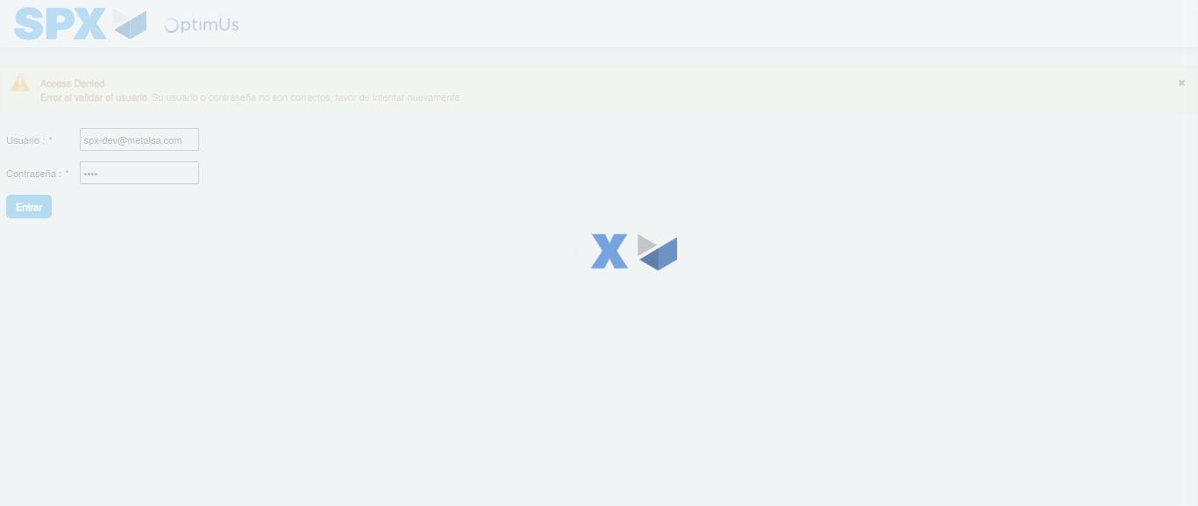Image file-name: QC_Testing-tc002_SPX_Dev5_Crear_Requisicion_Spot_Con_FAD_Tipo_Cobro_CC-1783354671921

Step 2 - Select to UEN and Access to Spot Buy Requisitions : UEN Correctly selected and Correct access
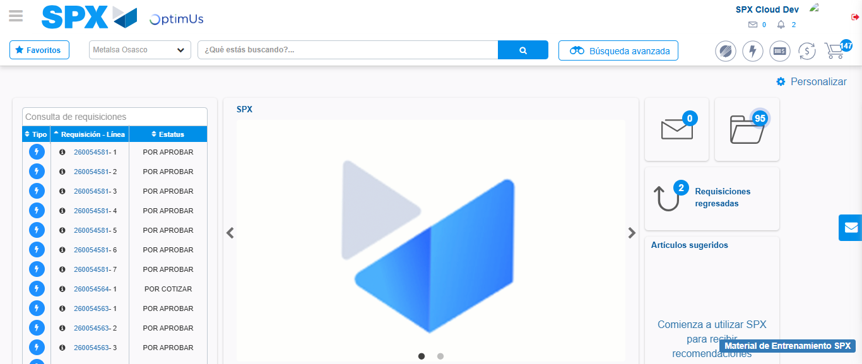Image file-name: QC_Testing-tc002_SPX_Dev5_Crear_Requisicion_Spot_Con_FAD_Tipo_Cobro_CC-1783354697860

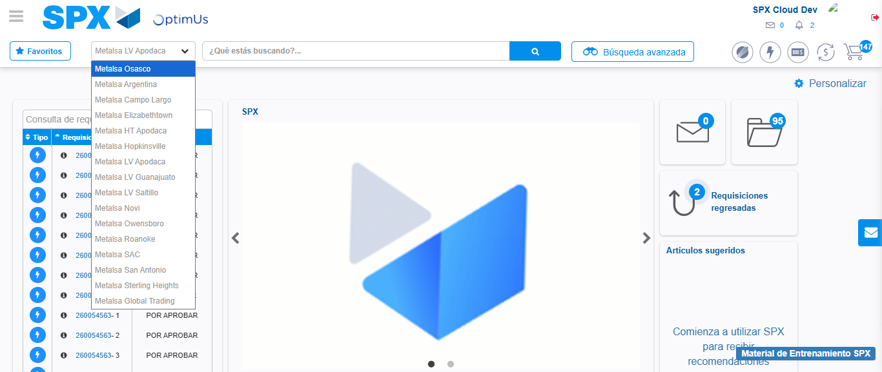Image file-name: QC_Testing-tc002_SPX_Dev5_Crear_Requisicion_Spot_Con_FAD_Tipo_Cobro_CC-1783354700499

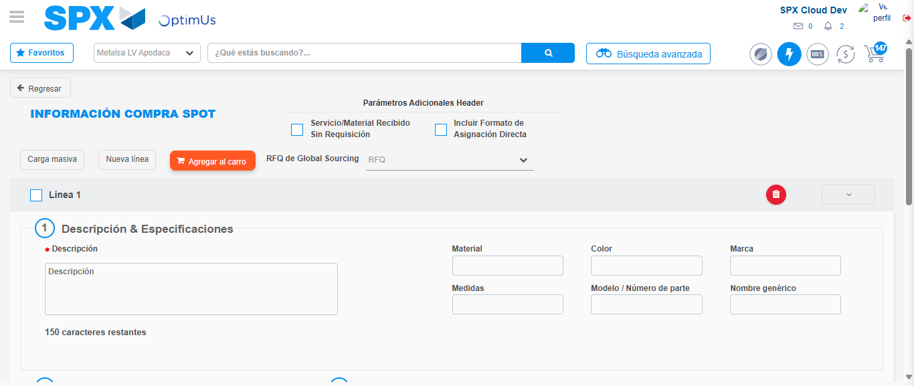Image file-name: QC_Testing-tc002_SPX_Dev5_Crear_Requisicion_Spot_Con_FAD_Tipo_Cobro_CC-1783354722876

Step 3 - Add FAD to Requisition: FAD Successfully Added
Image file-name: QC_Testing-tc002_SPX_Dev5_Crear_Requisicion_Spot_Con_FAD_Tipo_Cobro_CC-1783354723092

Image file-name: QC_Testing-tc002_SPX_Dev5_Crear_Requisicion_Spot_Con_FAD_Tipo_Cobro_CC-1783354723244

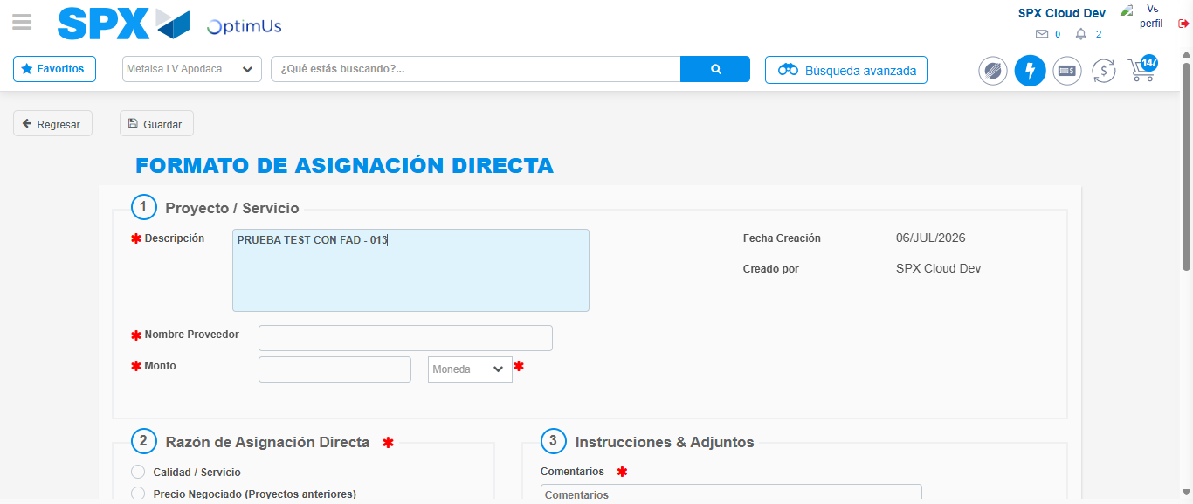Image file-name: QC_Testing-tc002_SPX_Dev5_Crear_Requisicion_Spot_Con_FAD_Tipo_Cobro_CC-1783354725856

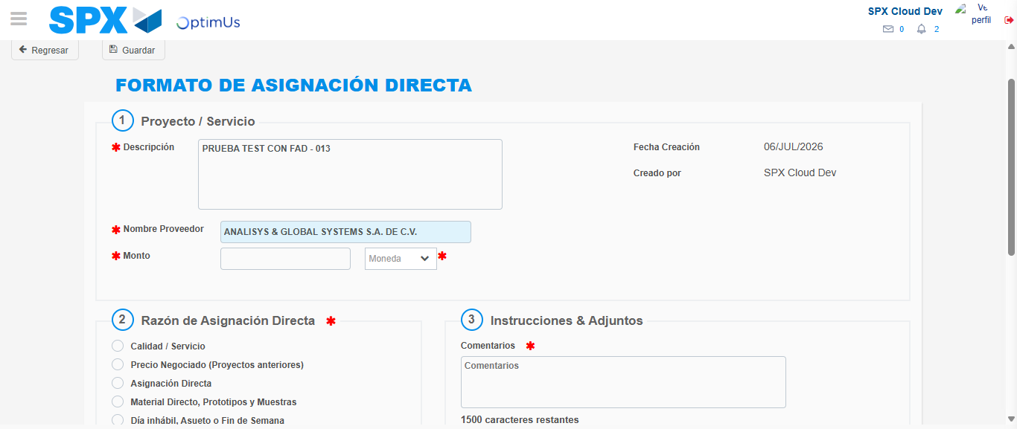Image file-name: QC_Testing-tc002_SPX_Dev5_Crear_Requisicion_Spot_Con_FAD_Tipo_Cobro_CC-1783354732377

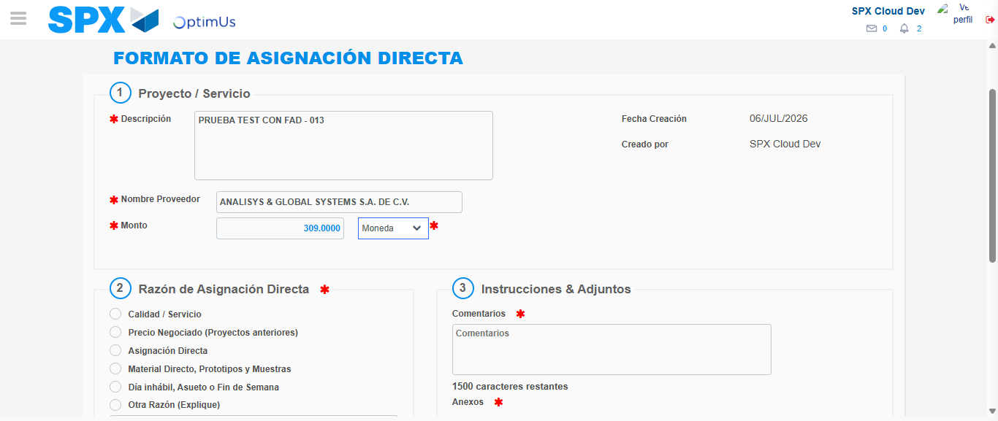Image file-name: QC_Testing-tc002_SPX_Dev5_Crear_Requisicion_Spot_Con_FAD_Tipo_Cobro_CC-1783354732825

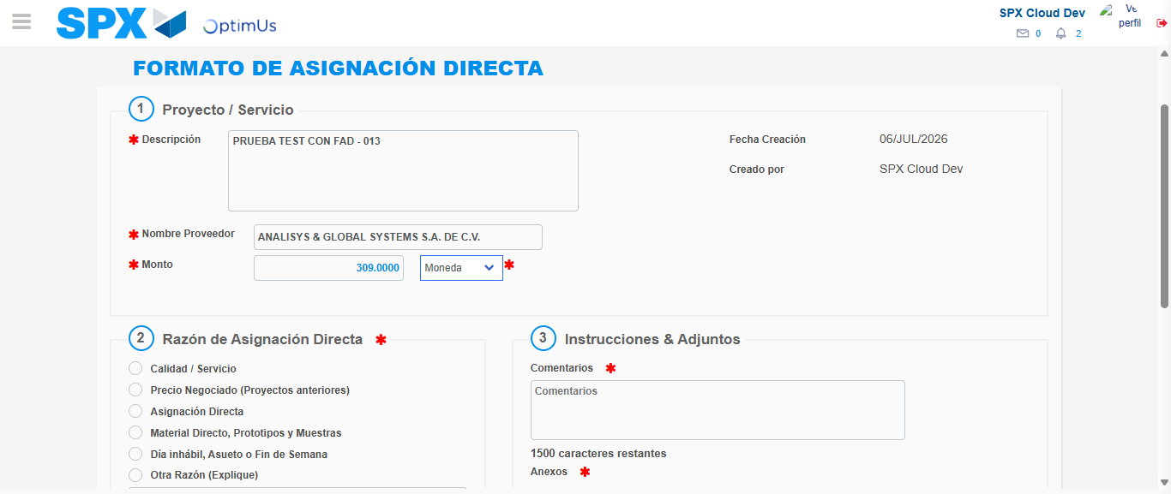Image file-name: QC_Testing-tc002_SPX_Dev5_Crear_Requisicion_Spot_Con_FAD_Tipo_Cobro_CC-1783354732992

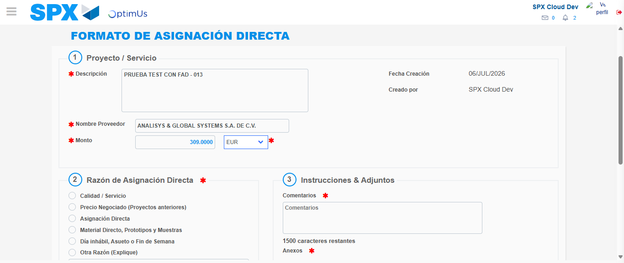Image file-name: QC_Testing-tc002_SPX_Dev5_Crear_Requisicion_Spot_Con_FAD_Tipo_Cobro_CC-1783354733370

Image file-name: QC_Testing-tc002_SPX_Dev5_Crear_Requisicion_Spot_Con_FAD_Tipo_Cobro_CC-1783354733532

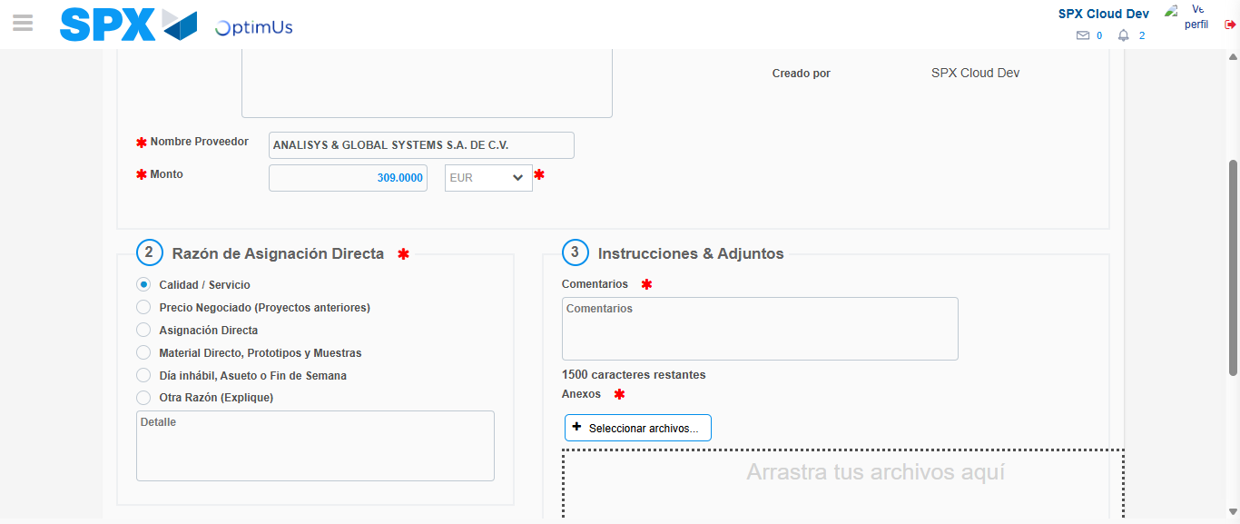Image file-name: QC_Testing-tc002_SPX_Dev5_Crear_Requisicion_Spot_Con_FAD_Tipo_Cobro_CC-1783354734389

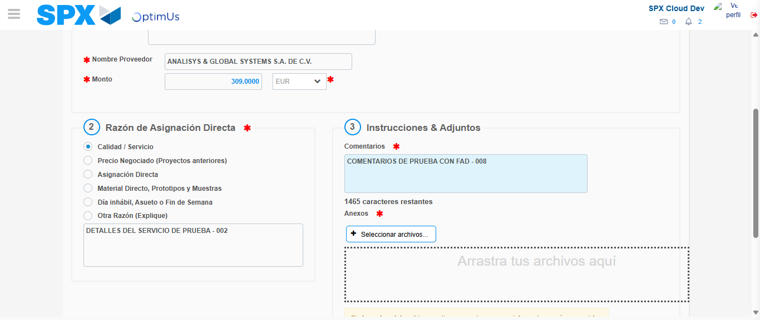Image file-name: QC_Testing-tc002_SPX_Dev5_Crear_Requisicion_Spot_Con_FAD_Tipo_Cobro_CC-1783354745429

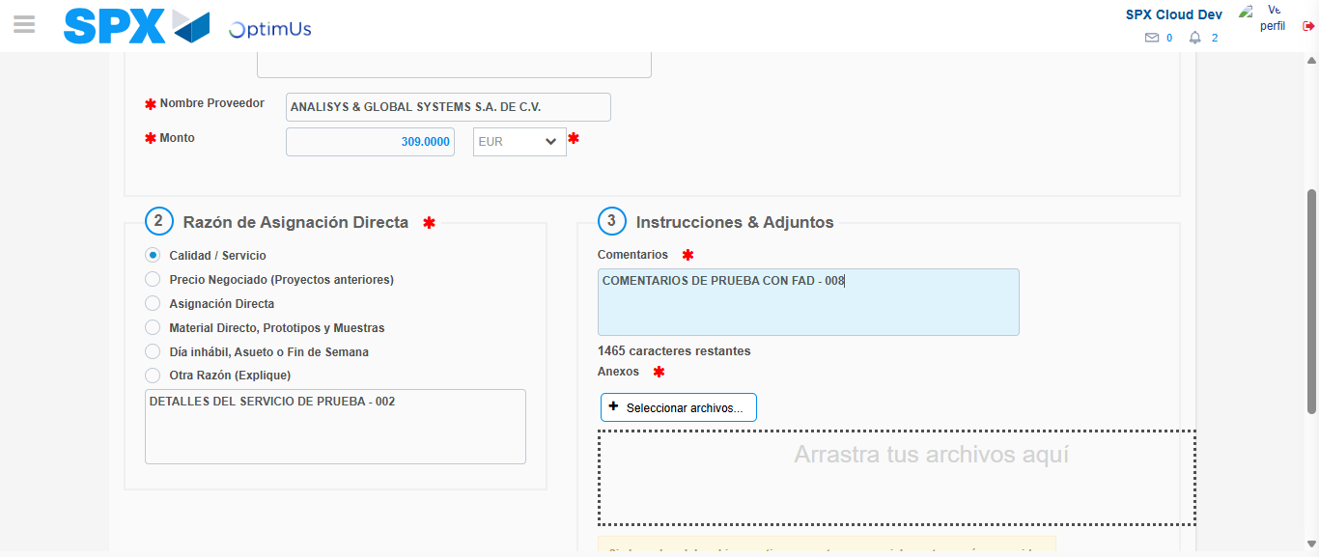Image file-name: QC_Testing-tc002_SPX_Dev5_Crear_Requisicion_Spot_Con_FAD_Tipo_Cobro_CC-1783354746124

Step 4 - Data Capture Spot Buy Requisition: Data captured correctly
Image file-name: QC_Testing-tc002_SPX_Dev5_Crear_Requisicion_Spot_Con_FAD_Tipo_Cobro_CC-1783354723092

Image file-name: QC_Testing-tc002_SPX_Dev5_Crear_Requisicion_Spot_Con_FAD_Tipo_Cobro_CC-1783354723244

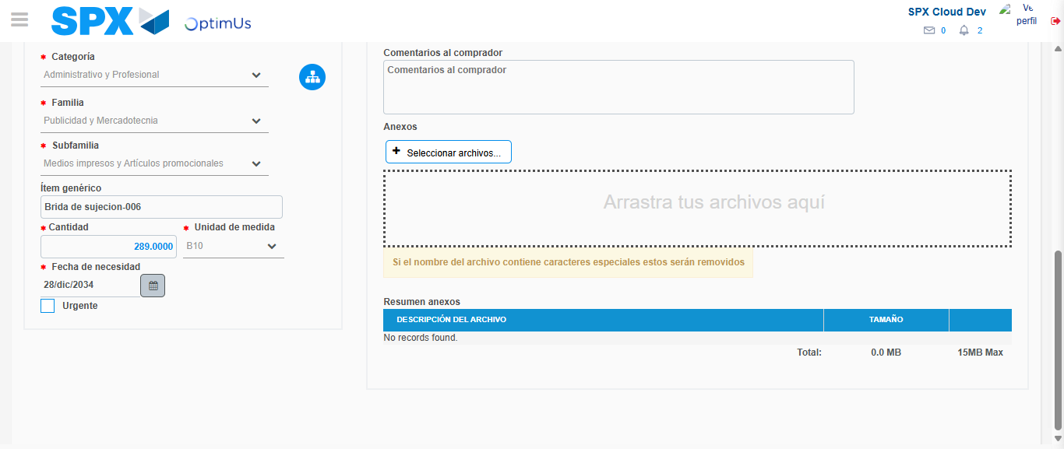Image file-name: QC_Testing-tc002_SPX_Dev5_Crear_Requisicion_Spot_Con_FAD_Tipo_Cobro_CC-1783354758184

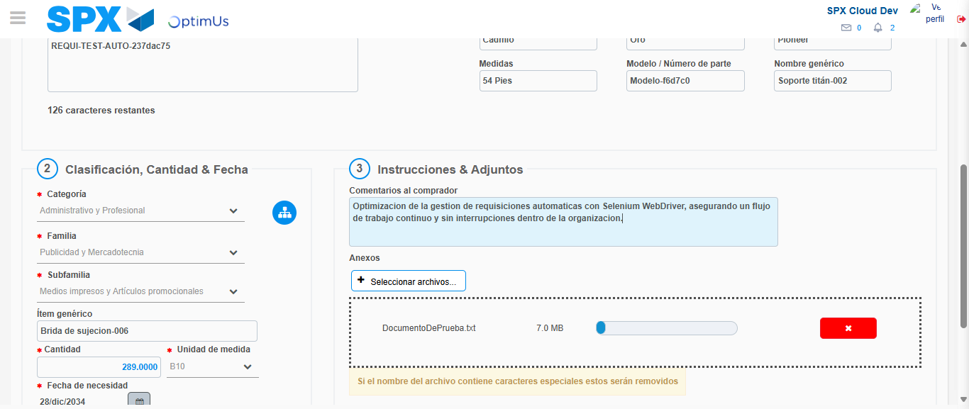Image file-name: QC_Testing-tc002_SPX_Dev5_Crear_Requisicion_Spot_Con_FAD_Tipo_Cobro_CC-1783354758965

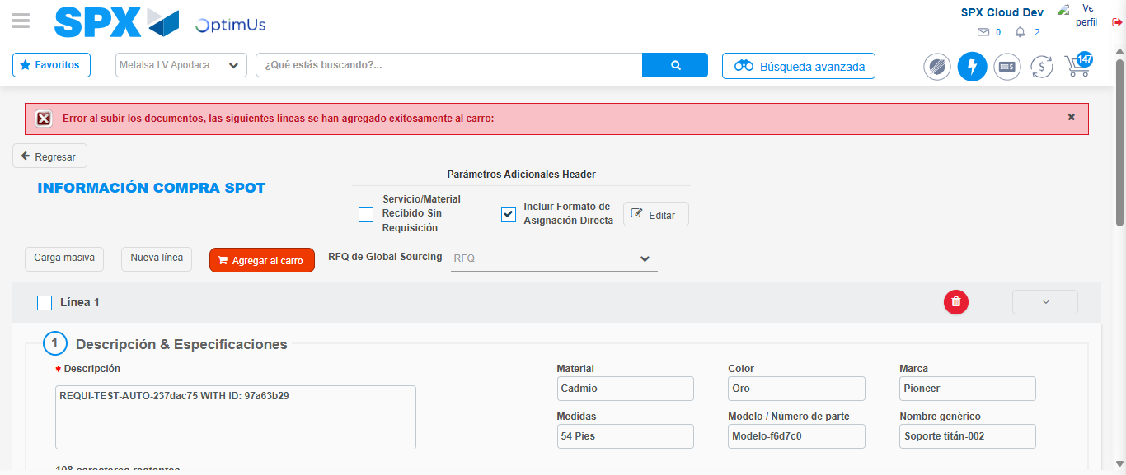Image file-name: QC_Testing-tc002_SPX_Dev5_Crear_Requisicion_Spot_Con_FAD_Tipo_Cobro_CC-1783354770590

Step 8 - Return to Main Page SPX : Return to Main Page SPX
Image file-name: QC_Testing-tc002_SPX_Dev5_Crear_Requisicion_Spot_Con_FAD_Tipo_Cobro_CC-1783354697860

Image file-name: QC_Testing-tc002_SPX_Dev5_Crear_Requisicion_Spot_Con_FAD_Tipo_Cobro_CC-1783354700499

Image file-name: QC_Testing-tc002_SPX_Dev5_Crear_Requisicion_Spot_Con_FAD_Tipo_Cobro_CC-1783354722876

Image file-name: QC_Testing-tc002_SPX_Dev5_Crear_Requisicion_Spot_Con_FAD_Tipo_Cobro_CC-1783354772784

Image file-name: QC_Testing-tc002_SPX_Dev5_Crear_Requisicion_Spot_Con_FAD_Tipo_Cobro_CC-1783354772949

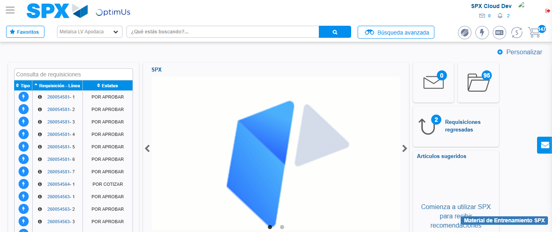Image file-name: QC_Testing-tc002_SPX_Dev5_Crear_Requisicion_Spot_Con_FAD_Tipo_Cobro_CC-1783354794147

Step 9 - Log Out : Log Out SPX
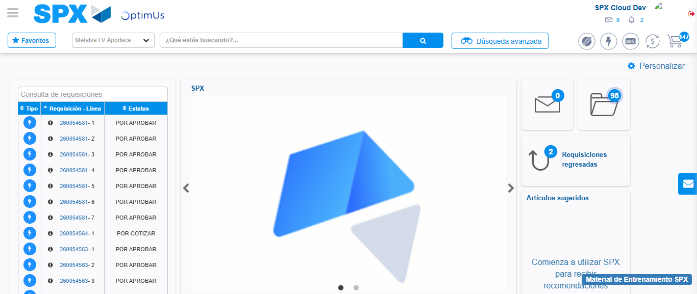Image file-name: QC_Testing-tc002_SPX_Dev5_Crear_Requisicion_Spot_Con_FAD_Tipo_Cobro_CC-1783354794495

